I've have had many requests to add 1964. But due to time constraints and a little laziness on my part, I have only added this emulator in January 2002. Which is a shame, because after trying it I can say for sure it's in the same "league" as Project 64, in other words, it's GOOD.  Getting the Plugins  By default 1964 already comes with a capable video plugin. However, as the authors admit themselves, it's not great. For a far better video plugin, copy Jabo's Direct3D video plugin from Project 64 to 1964's plugin directory. You can find Jabo's plugin in the plugin directory of Project 64.  The Newest plugin != Fastest plugin  One of my older PCs wasn't quite up to specs for running 1964. Though everything ran pretty fast with sound turned off, when I turned sound on the speed dropped considerably, below playable speeds. However, just by selecting an older version of Azimer's audio plugin gained much speed (but probably lost some quality). What this means is that you probably need to play with the settings and plugins a bit to get a combination that works best for you.  System Requirements  Emulating the Nintendo 64 is not easy. 1964 needs a reasonable PC to run comfortably.  - Pentium III 800 Mhz. or better  - GeForce 2 or better  - DirectX 8.0 or better  - 128 Mb. RAM or better  If your PC's specifications are less than this, you don't need to bother to even try to run 1964 as all games will run to slow to play.
  Screenshots
  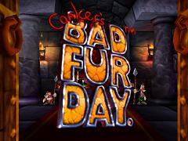
  Conker's Bad Fur Day
  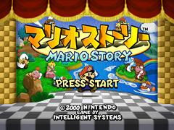
  Paper Mario
  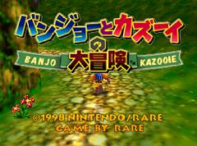
  Banjo Kazooie (Japanese version)

